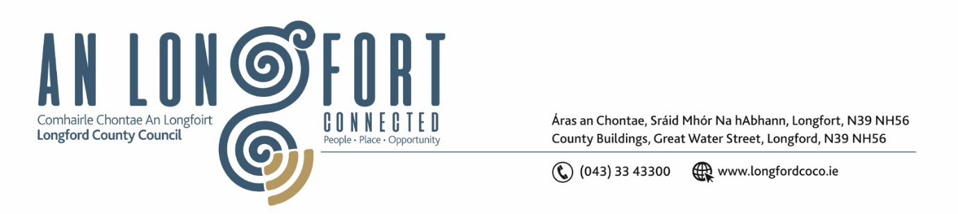

***LONGFORD MUNICIPAL DISTRICT***

***Please note meeting will be held in the Council Chamber, Aras an Chontae and via Microsoft Teams***

**20 April 2022.**

**To: Each Member of Longford Municipal District.**

**Dear Member,**

You are requested to attend the Meeting of Longford Municipal District to be held in **the Council Chamber, Aras An Chontae** and **via Microsoft Teams** on **Wednesday 27 April 2022 at 3.30pm** to transact business, as set out on the Agenda hereunder.

**Yours sincerely**,

Ann Marie Mc Keon

_______________

**Ann Marie Mc Keon**

**Meetings Administrator.**

**AGENDA**

Prayer before meeting.

**1.** Confirmation of Minutes -

1. Longford Municipal District Meeting held on Wednesday 23 March 2022– copy enclosed.
2. Longford Municipal District Committee Meeting held on Wednesday 23 March 2022 – copy enclosed.
3. Longford Municipal District Committee Meeting held on Friday 1 April 2022 – copy enclosed.

**2.** Matters arising from Minutes.

**3.** Declaration of Interest by Members.

**4.** Presentation on Longford Town Plan.

**5.** Management Report - enclosed.

**6**. Proposed Projects/Expression of interests.

**7.** Consideration of Public Art Installation/Relocation – Report enclosed.

**8.** Consideration of Adoption of Part 8, Number 89 in Accordance with Section 179 of the Planning and Development Act 2000 (as amended) and Part 8 of the Planning & Development Regulations 2001 (As Amended) – Proposed alterations and extension to Number 24 Congress Terrace and construction of new Semi-detached 2 storey 3 bed unit to side/rear garden area and all associated site works at 24 Congress Terrace, St. Michael’s Road, Townspark, Longford - Report enclosed.

**9. Notices of Motions, submitted by Councillors, as listed hereunder –**

**Councillor Seamus Butler**

That Longford Municipal District migrate to a Parking App System similar to the system operating in County Tipperary. This will save the outmoded coin system with its security risks and expensive coin collection’